**ChemSearch Instruction Manual**

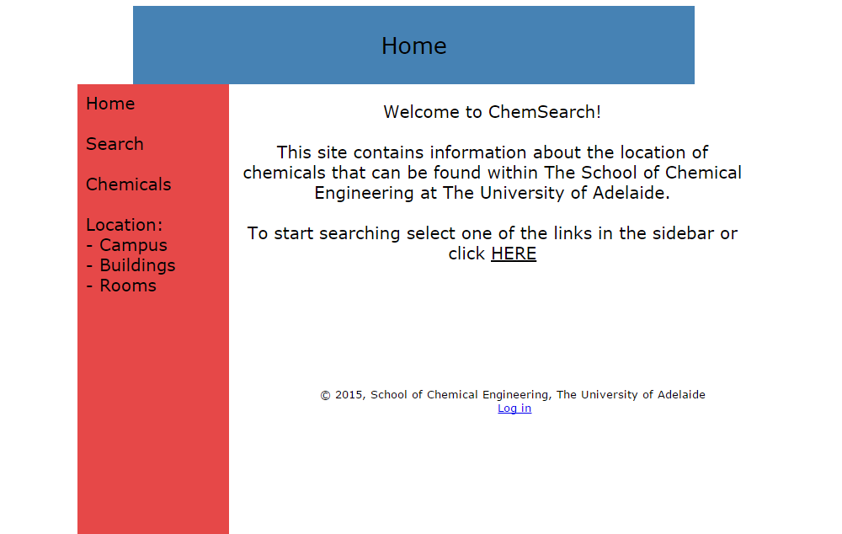

**Search**

*Option 1:*

Type in the name of a chemical and ChemSearch will display which rooms/labs this chemical is present in.

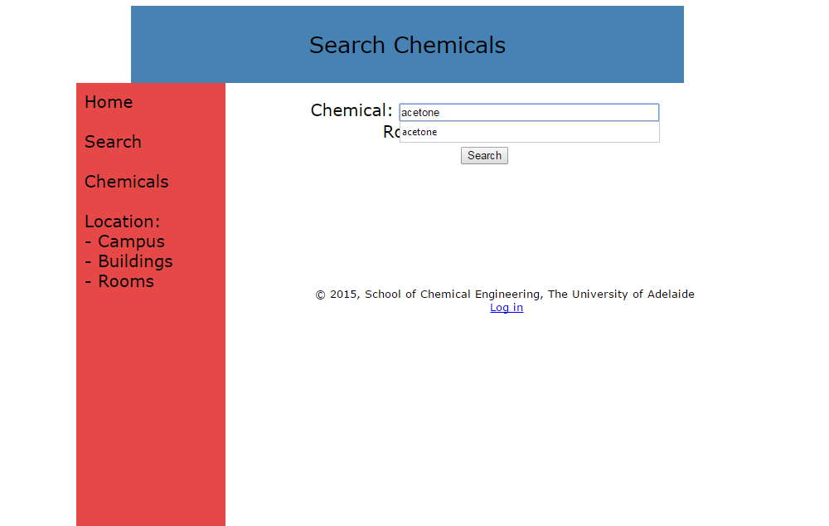

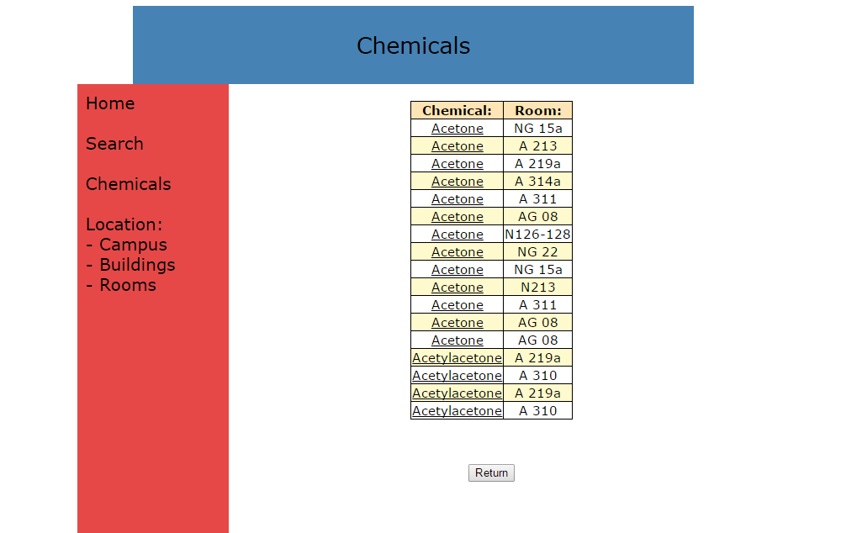

*Note that the search function is not restricted purely to what is written in the search bar. For example, searching for ‘acetone’ will return acetone as well any chemical with acetone in its name, such as acetylacetone.

*Option 2:*

Type in a lab number to display a list of chemicals present in that lab.

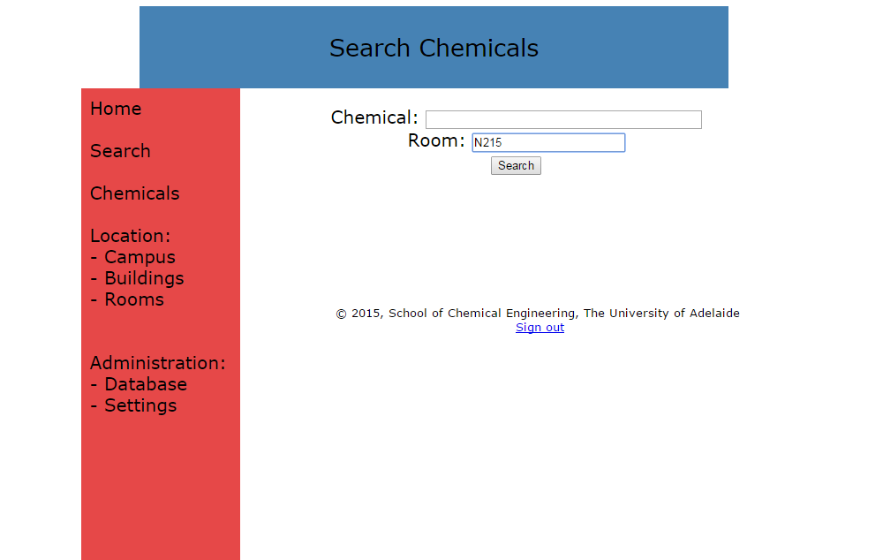

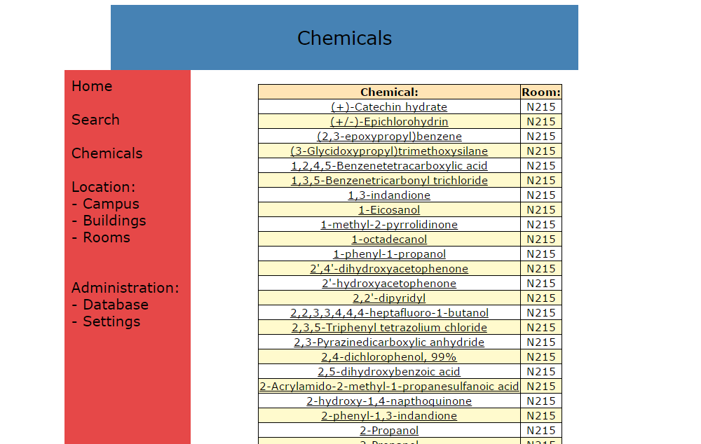

*Option 3*

Type in both a chemical name and a lab number to find out if that chemical is present in a specific lab.

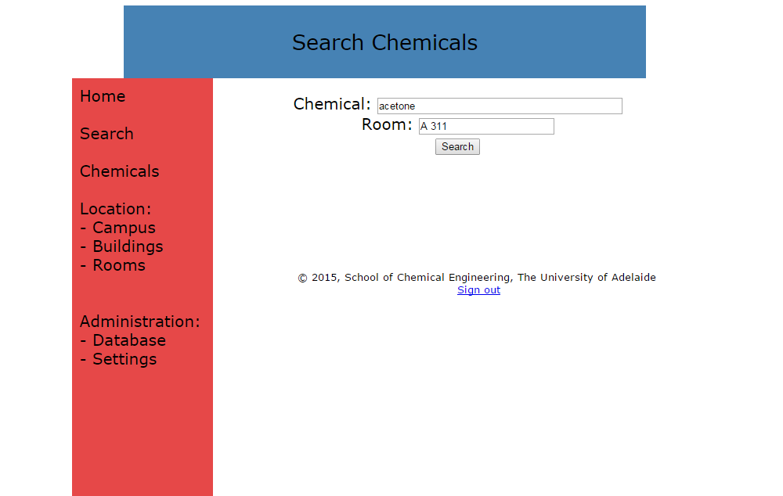

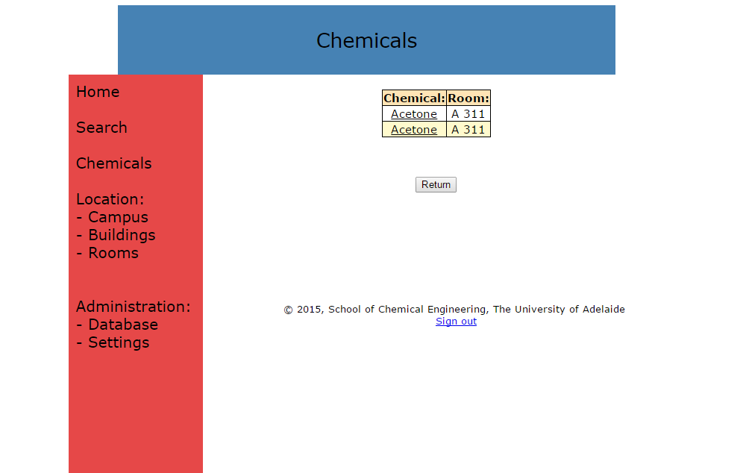

If not, the search will return ‘No chemicals found’.

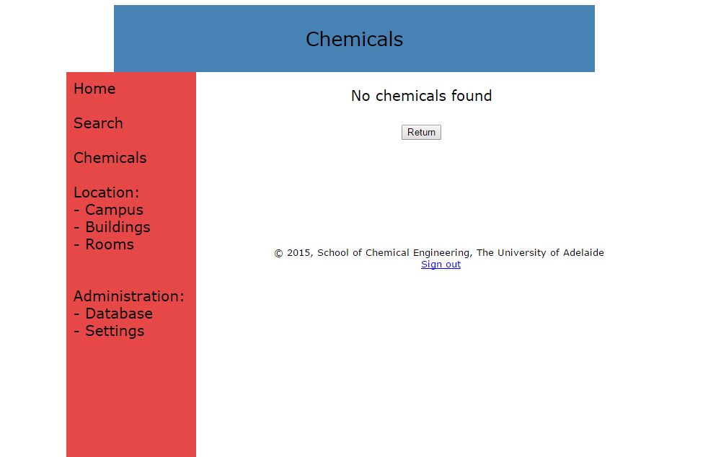

In each case, once search results have been returned, click on the chemical name to display additional information such as quantity, supplier and safety information.

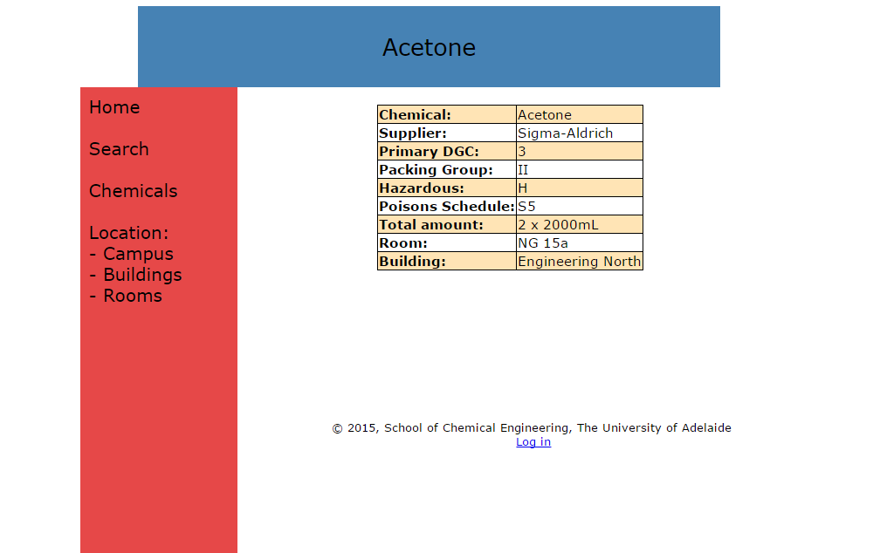

**Chemicals**

Click on ‘Chemicals’ in the side bar to return a list of all chemicals in the database, presented in alphabetical order. 25 chemicals are displayed per page; click the ‘Next’ button to navigate to the next 25 chemicals. Again, click on a chemical name to display additional information.

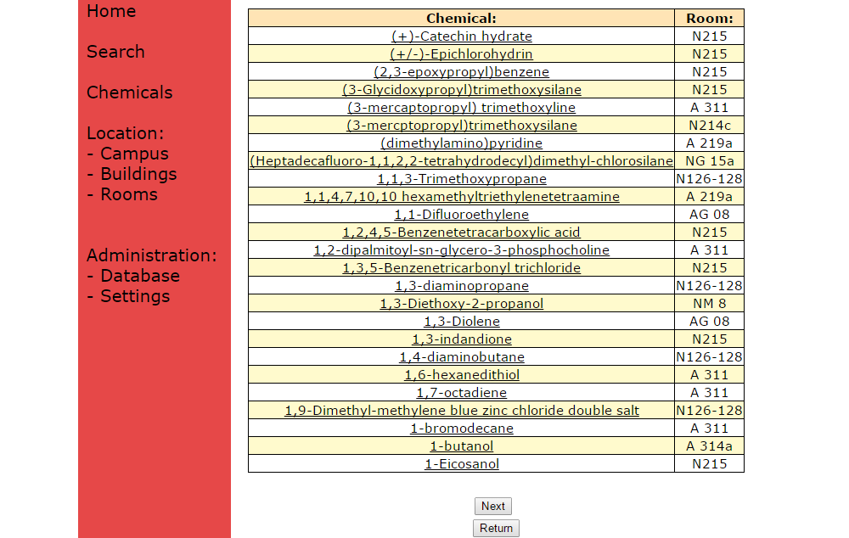

**Location**

Click on ‘Campus’ in the sidebar to display a list of Adelaide University campuses.

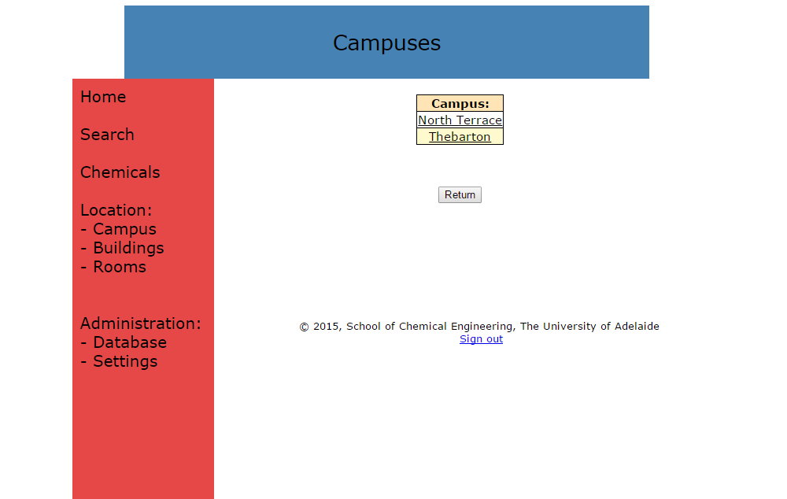

Click on a campus to display the list of Chemical Engineering buildings at that campus.

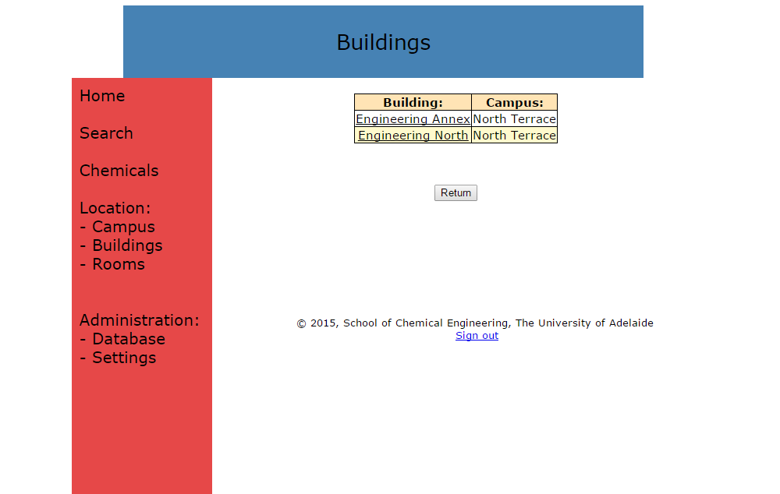

Click on a building name to display the list of Chemical Engineering labs in that building.

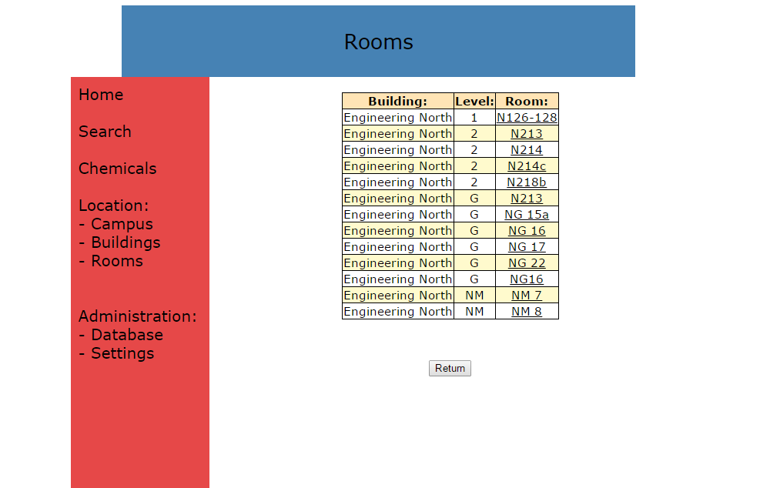

Click on a lab to return a list of chemicals present in that lab.



Again, clicking on the chemical name will display the associated additional information.

Alternatively, you can navigate directly to the list of buildings or labs/rooms by clicking on the relevant link in the sidebar.

**Administration**

**First time setup (No administrators present yet)**

Click on the ‘Log In’ link at the bottom of the page.

Fill out the form to create your administrator account.

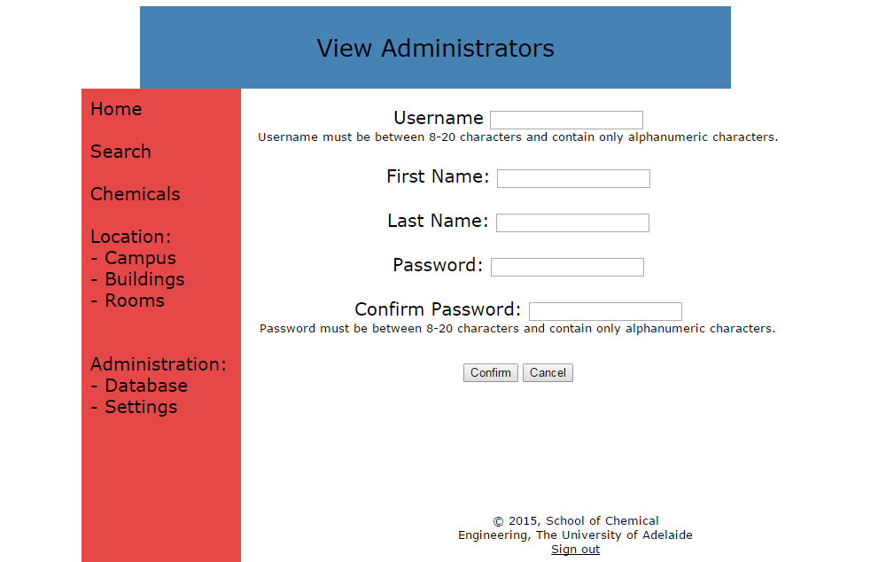

If you have done this correctly, the program should return the message ‘Administrator successfully added’.

**After an administrator has been created**

After adding an administrator, if you now click on the ‘Log In’ link you will instead be asked to enter your username and password:

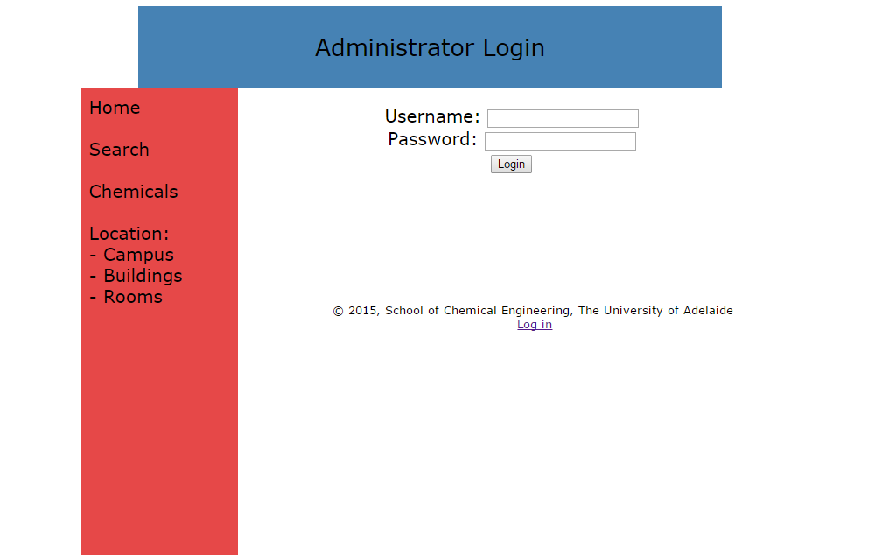

Once this you have successfully logged in as an administrator, the ‘Administration’ link in the sidebar will appear. Clicking on this directs you to the following page:

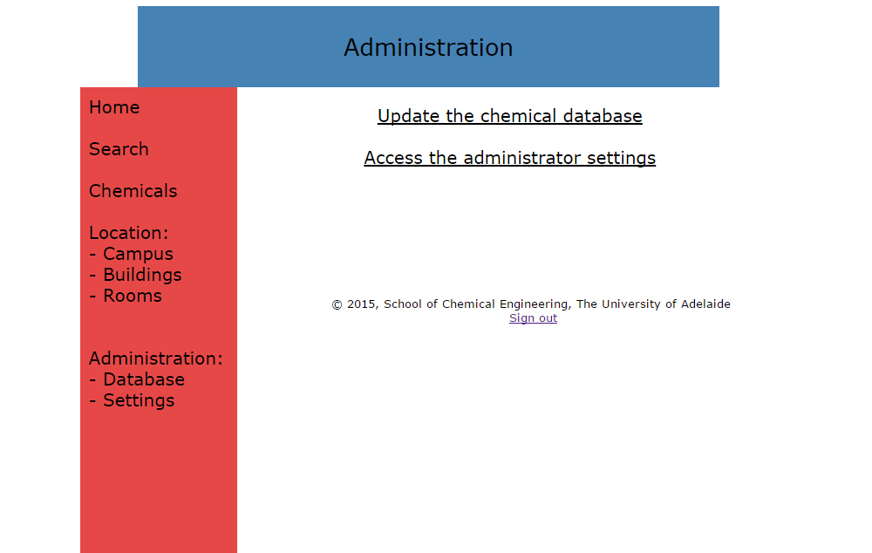

**Update the Chemical Database**

Clicking ‘Update the Equipment Database’ or the ‘Database’ link in the sidebar will send you to the following page: 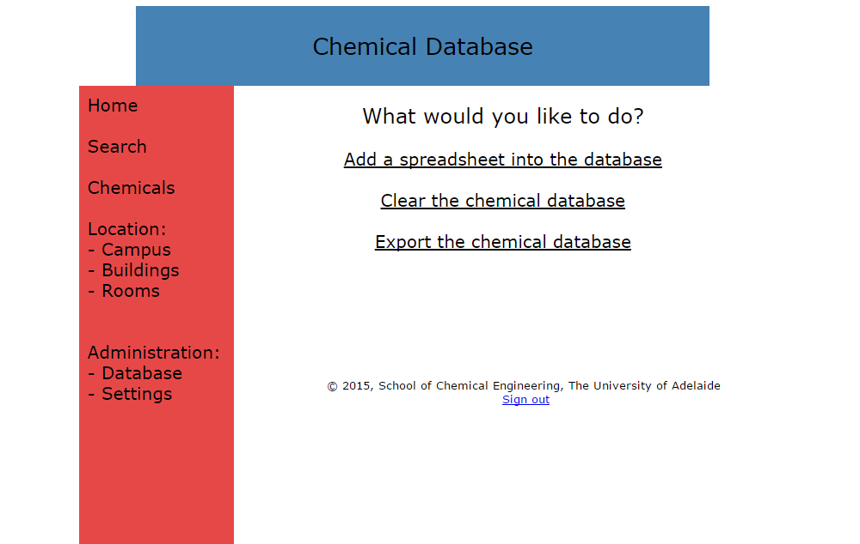

Click on one of the links to perform that function.

**Add a spreadsheet into the database**

After clicking on this link, you will be able to upload an Excel file containing the chemical database.

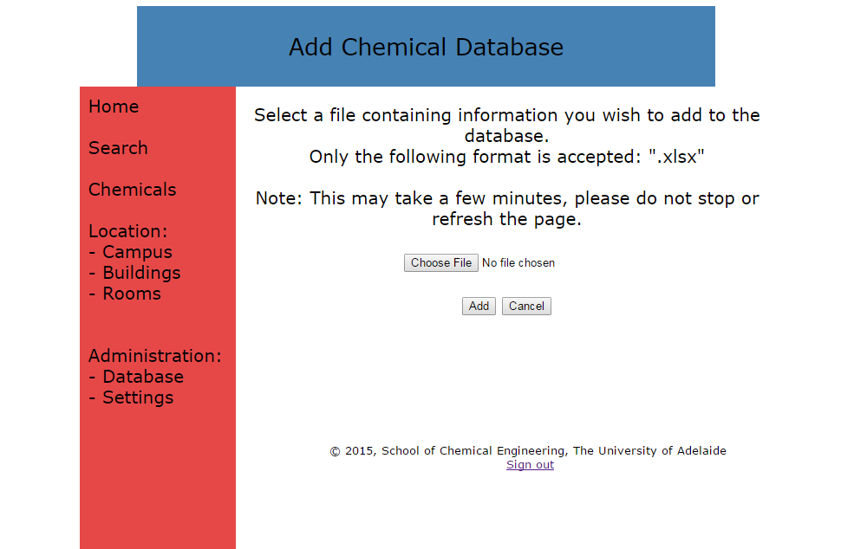

Select the desired file by clicking ‘Choose File’

Upload the file by clicking the ‘Add’ button.

THE SPREADSHEET MUST BE IN THE CORRECT FORMAT TO FUCTION CORRECTLY.

THE PROGRAM ONLY SUPPORTS .XLSX FILES.

Uploading will take up to a few minutes – DO NOT CLICK THE ADD BUTTON REPEATEDLY.

**It is possible for multiple files to be added to the program. The program will compile multiple files into a single database.**

**Clear the chemical database**

After following this link, click on the ‘Clear’ button to remove the entire chemical database from the ChemSearch program.

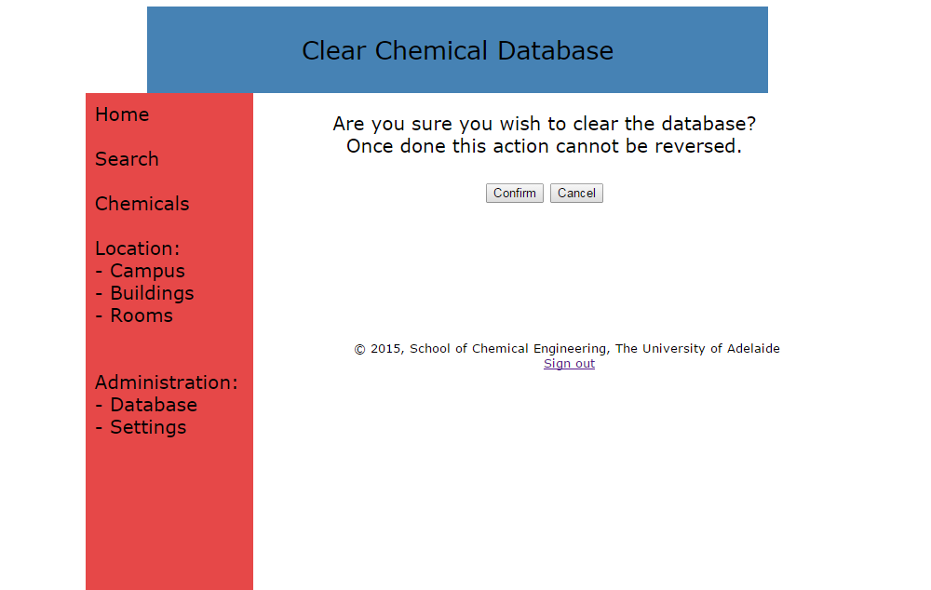

**Export the chemical database**

Clicking this link will direct you to the following page:

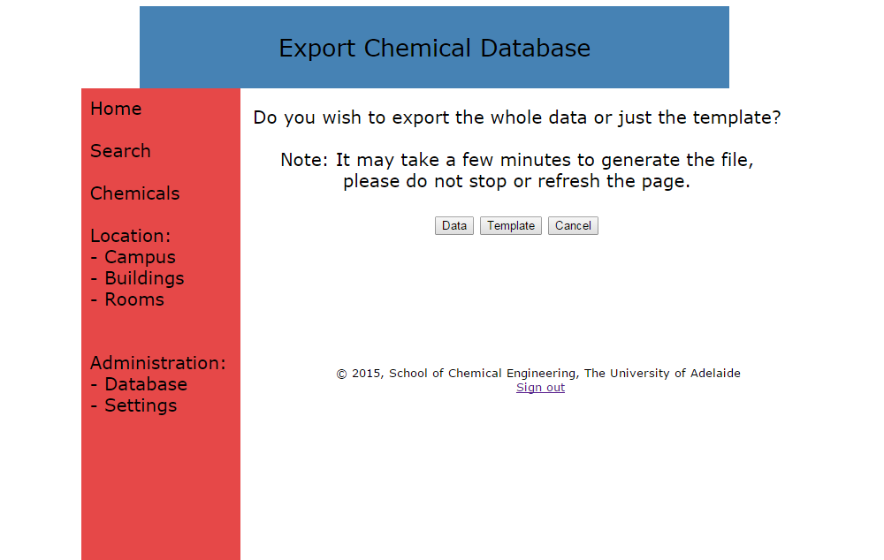

Click the ‘Data’ button to generate a .xlsx file containing the entire chemical database.

Downloading will take up to a few minutes – DO NOT CLICK THE DATA BUTTON REPEATEDTLY

*Note that the file created will have default row and column widths so some adjustments may be necessary to properly read the file.

EXPORTING THE CHEMICAL DATABASE **WILL NOT** CLEAR THE CHEMICAL DATABASE.

Clicking the ‘Template’ button will generate an empty .xlsx template of the chemical database in the correct format for uploading:

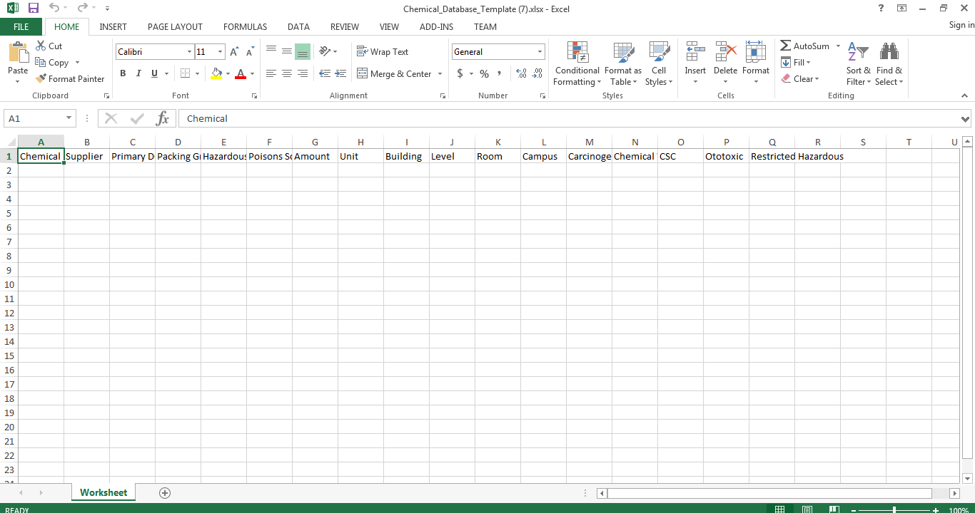

**Access the administrator settings**

**Add a new administrator**

Following this link allows you to add a new administrator. Once a new administrator has been added, they too will have the capability to update the chemical database and access the administrator settings. Just fill out the form to add a new administrator:



**View administrators**

Clicking this link will show you a list of all current administrators. You can also remove an administrator from this page.

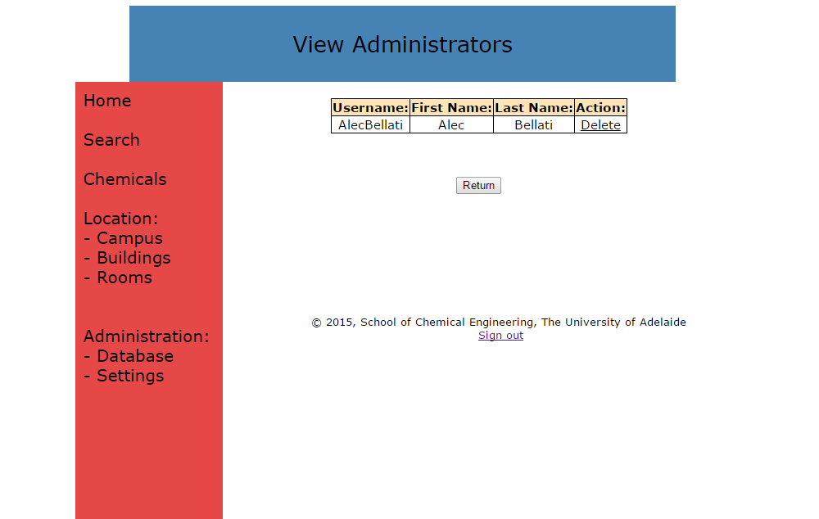

**Change Password**

Change the password you use to log in as an administrator.

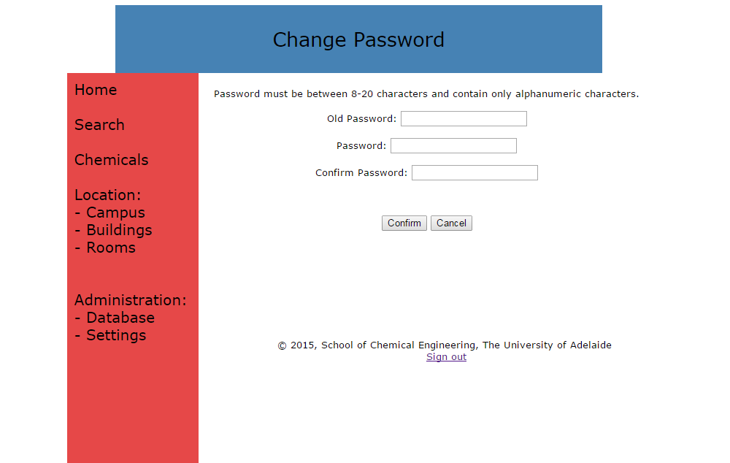

**Sign Out**

Clicking ‘Sign Out’ will remove the administration tab in the sidebar, preventing any further modifications to the database. Log in once again to perform further modifications.

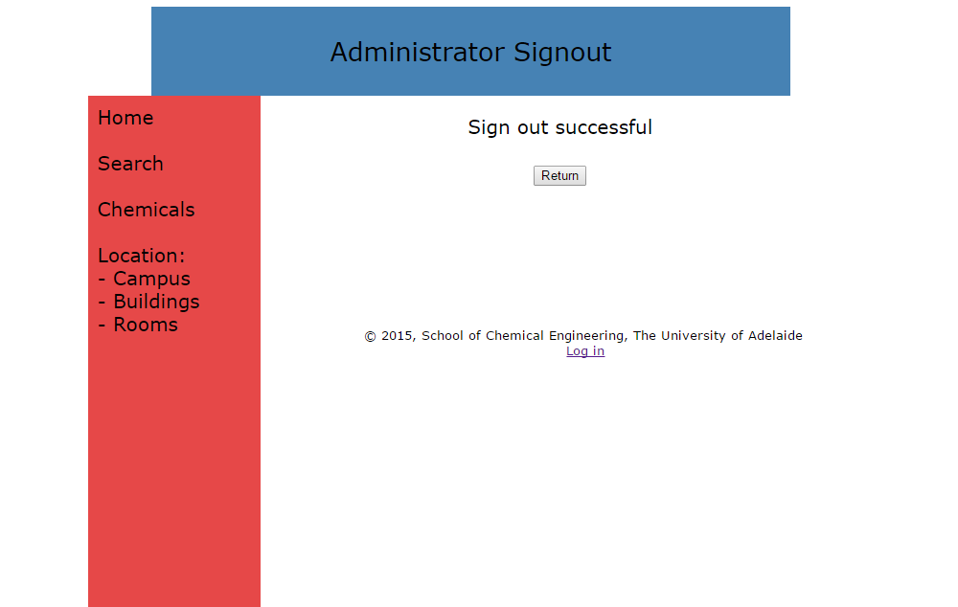

**ChemWatch**

Clicking on this link will direct you to the ChemWatch home page, where you can search for the MSDS of a particular chemical.